Discrete uniform distribution

Def

A symmetric probability distribution

wherein a finite number of values that are equally likely to be observed.

Annotation



Parameter



Support

正在插入影像...

PDF

= , if ==

= , otherwise

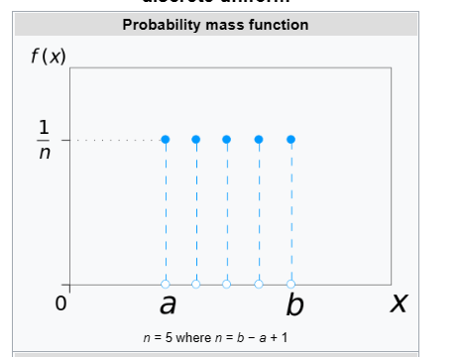

CDF

$$F\left(x;a,b\right)$$

= $$\frac{\left(floor\left(k\right)−a+1\right)}{b−a+1}$$, if $$k belongs to \left[a,b\right]$$

= $$0$$, otherwise

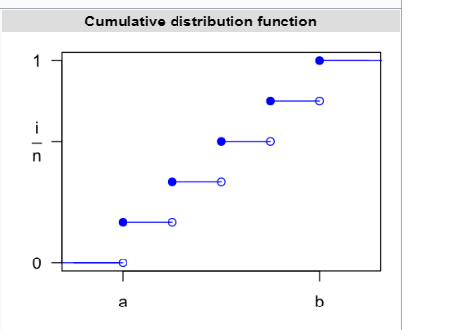

Expected Value



Variance



Median



Mode



Skewness



Ex. Kurtosis



Entropy



MGF



CF

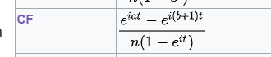

PGF



Ref

[Discrete uniform distribution - Wikipedia](https://en.wikipedia.org/wiki/Discrete_uniform_distribution)